**Hello Team!** **Consider the below two tables**:

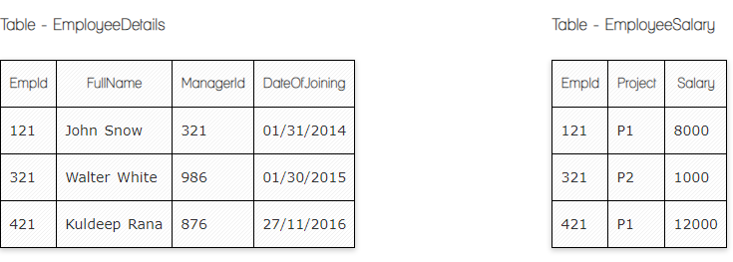

**Ques.1. Write a SQL query to fetch the count of employees working in project 'P1'.**

**Your Answer:**

**Select (Empid)**

**From EmployeeSalery**

**Where Project =”P1”**

**Ques.2. Write a SQL query to fetch employee names having salary greater than or equal to 5000 and less than or equal 10000.**

**Your Answer:**

**Select EmployeeNames**

**From EmployeeDetails**

**Left Join EmployeeSalary**

**On EmployeeDetails.EMPID=EmployeeSalary.EMPID**

**Where Salary between 5000 and 10000;**

**Ques.3. Write a SQL query to fetch count of employees sorted by project's count in descending order.**

**Your Answer:**

**Ques.4. Write a query to fetch employee names and salary records. Return employee details even if the salary record is not present for the employee.**

**Your Answer:**

**Ques.5. Write a SQL query to create an empty table with ‘Test’ name.**

**Your Answer:**

**Ques.6. Write a SQL query to delete an empty table with ‘Test’ name.**

**Your Answer:**

**Ques.7. Write a SQL query to fetch all the Employees details from EmployeeDetails table who joined in Year 2016.**

**Your Answer:**

**Ques.8. Write a SQL query to insert new record to the EmployeeDetails table with any data.**

**Your Answer:**

**Ques.9. Write a SQL query to update EmployeeSalery table with setting Salary to 2000 for Project P2.**

**Your Answer:**

**Ques.10. Write a SQL query to right join both tables and draw the results.**

**Your Answer:**

**Now take these two tables:**

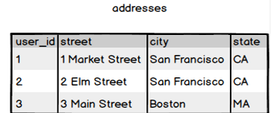

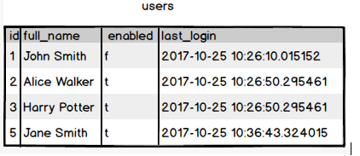

**Ques.11. Write a SQL query to fetch all users full_name from San Francisco.**

**Your Answer:**

**Ques.12. Write a SQL query to fetch all users full_name, last_login who are enabled**

**Your Answer:**

**Ques.13. Write a SQL query to fetch all users full_name who are not from Main street**

**Your Answer:**

**Ques.14. Write a SQL query to fetch all users full_name who are from Main street or San Francisco**

**Your Answer:**

**Ques.15. Write a SQL query to fetch user full_name who is equal to user_id from Boston (find user_id value in sub_query)**

**Your Answer:**